
SHIRE HIGHLANDS EDUCATION DIVISION
2025 MALAWI SCHOOL CERTIFICATE OF EDUCATION MOCK
EXAMINATION

MATHEMATICS
Subject Number: M0131/II
Friday, 28th March, Time Allowed: 2 hours 30 min
8:00 - 10:30 am

PAPER II
(100 Marks)

Question Number | Tick if answered | Do not write in these columns
1

2

3

4

5

6

7

8

9

10

11

12

Instructions
- This paper contains 14 printed pages. Please check.

- Write your Candidate ID at the top of each page in the space provided.

- Answer all the six questions in section A and any four questions from section B.

- Section A carries 60 marks and section B carries 40 marks

- The maximum number of marks for each answer is indicated against each question.

- Write your answers in the spaces provided on the question paper

- Calculators may be used.

- All working must be clearly shown.

- In the table provided on this page, tick against the question number you have answered.


© 2025 SHED
Turn Over

Section A (60 marks)
Answer all the six questions in this section
- a) Given that ${Log}_{6}5=1.1133$, find ${Log}_{6}180$ (5 marks)

b) Simplify $\frac{\sqrt{6}}{3\sqrt{8}+2\sqrt{3}}$ ,leaving the answer with a rational denominator. (6 marks)

- a) The first three terms of AP are (n -2), (3n -7) and (2n +6). Find the value of n. (5 marks)

b) Figure 1 shows triangle PQR in which PQ = 3m, PR = 8m and angle RPQ = $x°$.

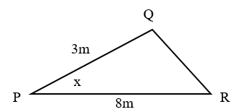

Figure 1

Given that the area of triangle PQR is $6\sqrt{3}m^{2}$, find the value of x. (5 marks)

- a) Given that P(-3, 6) , Q(9, -5) and R(33, y) are collinear points, find the value of y. (4 marks)

b) Prove that the angle subtended by the diameter at the circumference is a right angle. (4 marks)

- a) Table 1 data shows the ages of learners in a class.
Table 1
Class | 10 – 16 | 17 – 23 |  | 31 - 37
Frequency | 5 | 3 | 2 | 6

Complete the table and use it to find the mean of grouped data. (5 marks)

b) A sailor moves 6km from point A to B on a bearing of $147°$. He then moves 9km from point B to C on a bearing of $245°$. Calculate the distance between A and C. (6 marks)

- a) Figure 2 shows the graph of an equation of the form $y=ax^{2}+bx+c$.
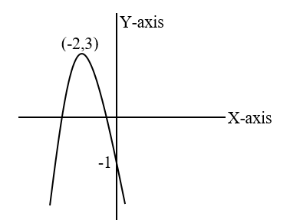

Figure 2

Find the equation of the graph. (5 marks)

b) Simplify $\frac{t^{2}-25}{30-6t}÷\frac{2t^{2}+7t-15}{3t}$ (5 marks)

- a) Given that $n\left(B^{'}∩A\right)= 12, n\left(A^{'}∩B\right)=9$and$n\left(A∪B\right)=26$, find
$n(A∩B)$ (4 marks)

b) Figure 3 is a dog house made using wooden pyramid and a cube of side 6m. The edge of the pyramid is 5m long.
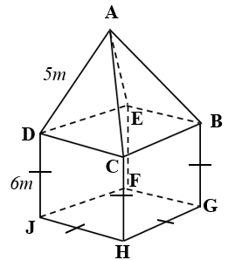

Figure 3

If the floor of the house is made of cement, calculate the surface area of the wood used to make the house. (6 marks)

Section B (40 marks)
Answer any four questions from this section in the spaces provided

- The probability that it is sunny in Panchenga town is $\frac{1}{3}$, the probability that it rains in the same town is $\frac{2}{5}$ while the probability that Chisomo leaves the town is $\frac{3}{4}$. Using a tree diagram find the probability that Chisomo will leave Panchenga town whether while it is raining or not. (10 marks)

- Solve the following simultaneous equations $\frac{6}{a}+b=7$
$b-a=2$ (10 marks)

- A fruit juice is made by mixing x litres of mangoes juice and y litres of guava juice. The price of the final juice per litre, p varies with the volume of mango juice and the square of the volume of guava juice. A juice made using 6 litres of mango juice and 4 litres of guava juice sells at K10,000.00 per litre while juice made using 5 litres mango juice and 2 litres guava juice sells at K6,000.00 per litre. Find the price per litre of juice made using 7 litres mango and 3 litres guava. (10 marks)

- A salesperson sells sweets and biscuits. Sweets cost K2,000.00 per packet while biscuits cost K3,000.00 per packet when ordering. She has a shelf that can hold a maximum of 40 packets.She has a total of K90,000.00 to purchase his groceries. Taking x as the number of packets for sweets and y as the number of packets for biscuits,
- write down two inequalities for this information in addition to $x≥0$and$y≥0$ (2 marks)

- taking a scale of 2cm to represent 10 on the horizontal axis and 2cm to represent 5 units on the vertical axis, illustrate the region represented by the inequalities by shading the unwanted region. Use the graph on page 12. (5 marks)

- find the number of packets of each that she must buy to maximize his profit if each packet of sweets makes a profit of K1,000.00 while each packet of biscuits makes a profit of K1,200.00. (3 marks)

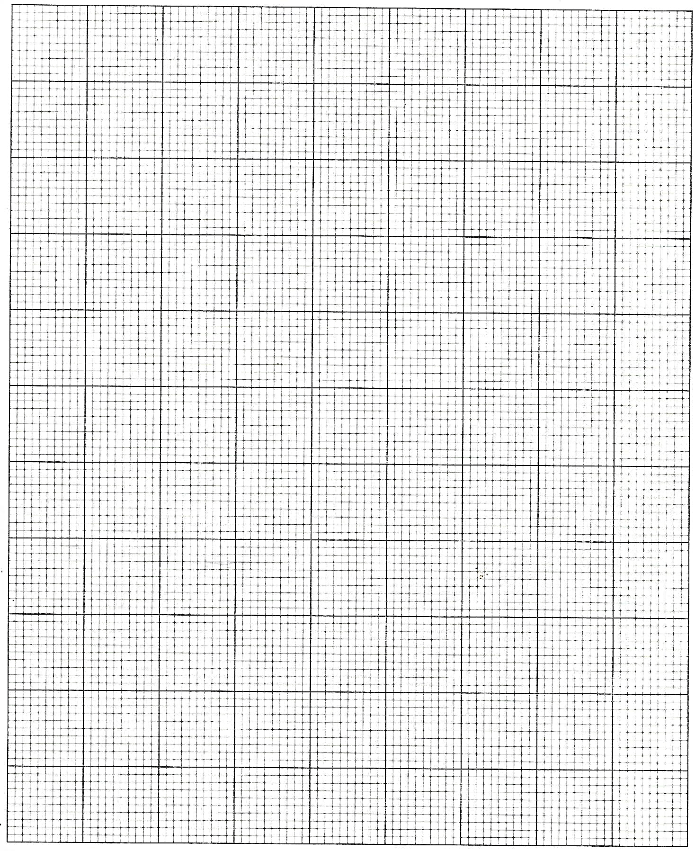

- On his way to Mzuzu, Bauleni covers a distance of 720Km. When returning, he drives 40km/hr faster and takes 3 hours less. Find his speed on his way to Mzuzu. (10 marks)

- Table 2 shows values of x and y for the equation $y=x^{3}-4x^{2}+x+6$
Table 2
$$y=x^{3}-4x^{2}+x+6$$
x | -2 | -1 | 0 | 1 | 2 | 3 | 4
y |  | 0 | 6 | 4 | 0 |  | 10

- Complete the table by filling the missing values of y. (2 marks)

- Using the scale of 2cm to represent 1 unit on the horizontal axis and a scale of 2cm to represent 5 units on the vertical axis, draw the graph of $y=x^{3}-4x^{2}+x+6$ on the graph paper provided at page 15 (5 marks)

- Use the graph to solve the equation $x^{3}-4x^{2}+2x-1=x-7$
(3 marks)





END OF QUESTION PAPER

